Test Project
  - Web Technologies
  - PHP and JavaScript Module
TW中英

Submitted by:

Sebastian Häni – CH (Independent Test Project Designer)
Cyril Wanner – CH (Independent Test Project Designer)
Patrick Zahnd – CH (Independent Test Project Designer)

Contents
Contents 2
Introduction 3
Description of project and tasks 3
Phase one – PHP 4
Database design 4
Organizer interface 4
Organizer login and logout 5
Event management 6
Ticket management 9
Session management 10
Channel management 12
Room management 13
Room capacity 14
Attendee API 15
Events overview 15
Event detail 16
Attendee login and logout 17
Event registration 18
Phase two – JavaScript 19
API Setup 19
Introduction 20
Events list 21
Event agenda 22
Session detail 23
Event registration 24
Attendee login 26
Notes 27
Submission Instructions to the Competitor 28
Equipment, machinery, installations, and materials required 29
Marking Scheme 29

Introduction介紹
The agency responsible for organizing the WorldSkills Conferences needs a new web application helping them to manage the events and allowing attendees to sign up and see all information they need. It should be dynamically built so that it can later be shared with other member organizations which means that multitenancy is an important requirement.
WorldSkills 研討會的主辦單位需要一款網頁應用程式，讓主辦單位可以管理活動，並且讓參加人員能報名、瀏覽所有需要的資訊。應用程式應為動態的，之後才能與其他協辦單位共享，意即，多人管理(multitenancy)是重要的要求。
Because this application will grow over time, important requirements are covered by automated tests.
這個應用程式會隨時間增進，因此很重要的要求是，要能夠自動測試。

Description of project and tasks專案和任務說明
The project is split into two phases: 這項專案分為兩階段：
- phase one (morning, 3 hrs) for building the backend parts (admin interface and REST-API) using PHP (framework) and database
第一階段(上午，三小時) 建立後台部分 (管理者介面及 REST-API)，方法是使用PHP(框架)和資料庫
- phase two (afternoon, 3 hrs) for building the frontend parts (attendee interface) using HTML/CSS/JS (framework) and the REST-API provided for phase two.
第二階段 (下午，三小時) 建立前台部分 (參加人員介面) 方法是使用HTML/CSS/JS(框架) 以及為第二階段提供的REST-API。

Phase one – PHP第一階段-PHP

Database design 資料庫設計
- Use your database (dbYY_competitor_day2) and import the schema/dump provided
請用你的資料庫 (dbYY_competitor_day2) 並且匯入以提供的schema/dump
- Extend your database to be able to store (do not modify/extend any existing table except if it is specifically noted as they will be resetted before every test run)
擴充你的資料庫，用以儲存 (請勿修改/擴充任何現有表格；若表格有特別註記，會在test run之前重新設定，則為例外)
  - Event ratings 活動評分
    - Attendees should be able to comment and rate events they have attended
參加人員應能夠對已參加的活動給予評論及評分
    - Rating should be a full number between 1 and 5, where 1 is the lowest and 5 the highest rating
評分應為介於1至5之間的整數，1為最低分而5為最高分
    - The date and time of the rating should be registered
給予評分的日期及時間應留有紀錄
  - Session ratings 場次評分
    - Additional to the event rating, attendees should be able to rate sessions they have attended
除了活動評分外，參加人員應能對已參加的場次給予評分
    - Rating should be a full number between 1 and 5, where 1 is the lowest and 5 the highest rating
評分應為介於1至5之間的整數，1為最低分而5為最高分
    - The date and time of the rating should be registered
給予評分的日期及時間應留有紀錄
- Your additional tables need to follow the third normal form.
你的新增表格需要符合第三正規化。

Organizer interface 主辦人介面
Create an organizer interface (Server Side Rendered using a PHP Framework) using the templates provided to
建立一個主辦人介面 (運用PHP框架做SSR伺服端渲染) 方法是使用已提供的模板，功能如下
- manage events, sessions, channels, rooms and tickets (create, read, update)
管理活動、場次、頻道、演講廳和票券 (建立、瀏覽、更新)
- create a bar chart to see the occupancy rates of all rooms
建立長條圖，用來看每間演講廳的報名率

- create dynamic ticket prices
建立動態的票價
- support multiple tenants
支援多人管理
Because different organizers will use this backend, keep security in mind. It should not be possible to access events of other organizers or update events of other organizers.
因為有不同的主辦人會使用這個後台，請留意安全性，使用者不可存取或更新其他主辦人的活動。

Organizer login and logout 主辦人登入及登出
Because registering as a new organizer is not within the scope of this project, please update the first two organizers in the provided dump so that it is possible to log in with the following credentials:
新的主辦人註冊功能並非此試題的範圍，因此，在已提供的dump裡面，請更新頭兩個主辦人，讓下列兩個身份可以登入：
- Email: demo1@worldskills.org Password: demopass1
- Email: demo2@worldskills.org Password: demopass2
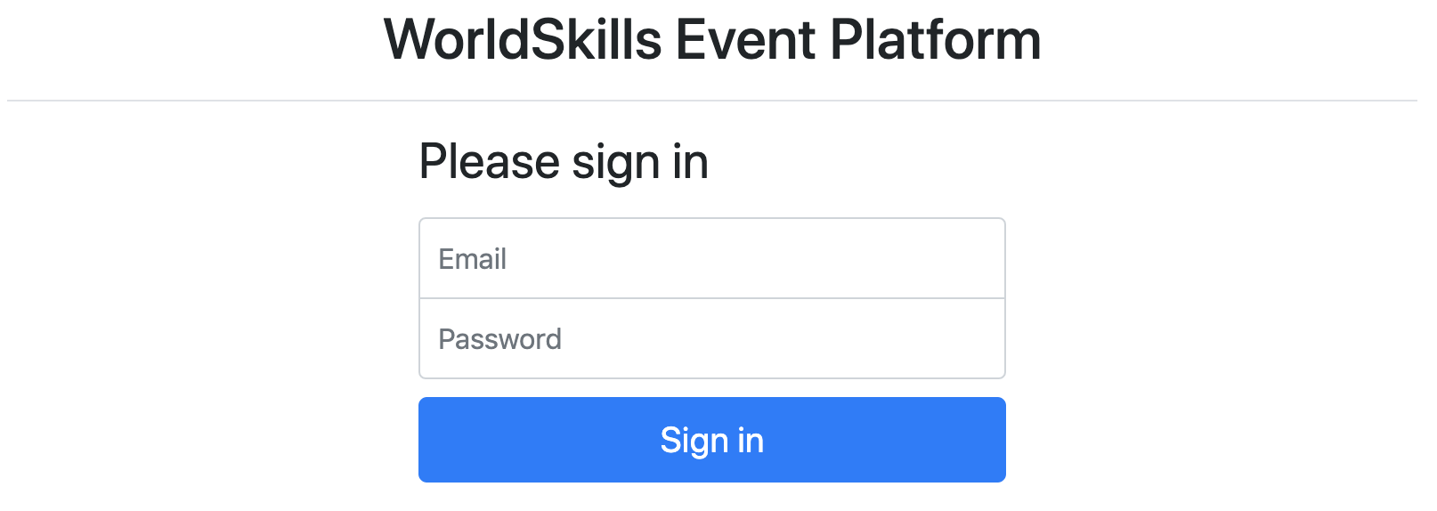
Specification: 規格：
Feature: A1 – Log in and log out as an organizer: As an organizer, I would like to log in and log out to the event platform so that I can access the functionality of the platform.
功能: A1 – 以主辦人身分登入及登出: 身為主辦人我想登入/登出活動平台，以存取平台功能。

Scenario: A1a - Organizer login ok
情境：A1a- 主辦人登入成功
Given I am on the "login" page
假設在login頁
When I enter the specified email and password for an organizer
若輸入正確的主辦人email和密碼
And press the "Sign in" button
按下 “Sign in”鈕
Then I am forwarded to the organizer area
就會轉到主辦人專區
And organizator name and "Sign out" button become visible in the header
在header顯示主辦人名稱和 "Sign out”鈕
And page "Manage events" becomes visible
能看見“Manage events”頁面

Scenario: A1b - Organizer login fail
情境：A1b-主辦人登入失敗
Given I am on the "login" page
假設在 “login”頁
When I enter a wrong email and password combination for an organizer
or use login information of an attendee instead of an organizer
主辦人email和密碼的組合輸入錯誤，或使用參加人員的登入資訊而非主辦人
And press the "Sign in" button
按下 “Sign in”鈕
Then I stay on the "login" page
就會停留在“login”頁
And I see an error message "Email or password not correct"
並看見錯誤訊息"Email or password not correct"

Scenario: A1c - Organizer logout
情境：A1c-主辦人登出
Given I am logged in
假設我已登入
When I press the "Sign out" button
按下"Sign out"鈕
Then I am forwarded to the "login" page
就會轉到 “login”頁
And organizator name and logout button and admin functions disappear
而主辦人名稱和logout鈕以及管理者功能都會消失
And I cannot reach the previous page by going back
且無法按上一頁回到先前的頁面

Event management 活動管理
Organizers should be able to save all information about an event and its sessions in the database. Every organizer account can only see and edit its own events. The organizer may have zero or many events.
主辦人應能夠將所有與活動及其場次相關的資訊，儲存進資料庫。每個主辦人帳號只能瀏覽和編輯自己的活動。主辦人可擁有零個或多個活動。
Specification: 規格：
Feature: A2 - Manage events: As an organizer I want to manage events so attendees can find events
功能：A2 -管理活動：身為主辦人，我想管理活動，好向參加人員宣傳

Scenario: A2a – List all events
情境：A2a-列出所有活動
Given I am logged in
假設我已登入
And I am on the "Manage events" page
在"Manage events"頁面
Then I see a list of all events created by the current organizer sorted
ascendingly by their date
會看到目前主辦人建立的所有活動的列表，依日期由先至後排列
And I see the total number of registrations for every event
並看見每個活動的總報名人數

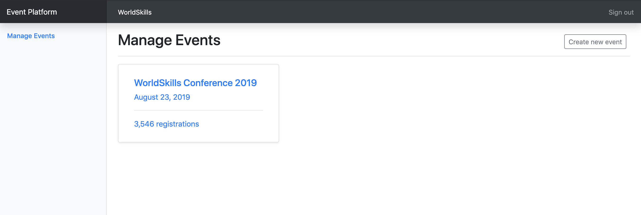

Scenario: A2b - Show form for new event
情境：A2b- 顯示新活動的表單
Given I am logged in
假設我已登入
And I am on the "Manage events" page
在"Manage events"頁面
When I press "Create new event"
按"Create new event"之後
Then a form to enter event information appears
會出現表單，可以輸入活動資訊

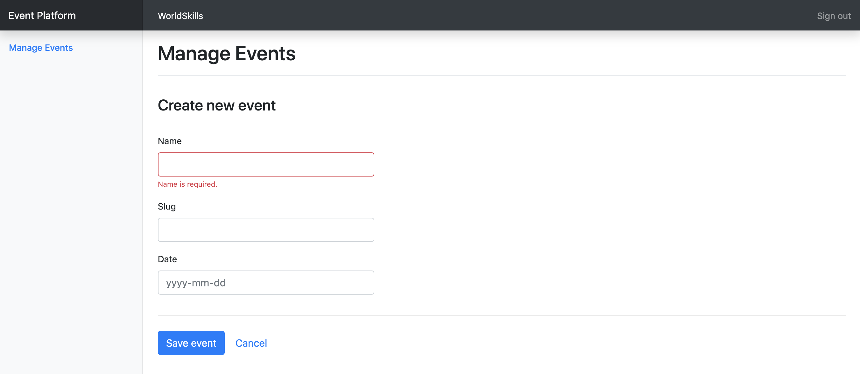

Scenario: A2c - Enter information for a new event
情境：A2c- 輸入新活動的資訊
Given a form to enter event information is shown
假設輸入活動資訊的表單已顯示
When I enter info for the event (all fields required)
輸入活動資訊後(所有欄位皆必填)
And I press "Save event"
按下 “儲存活動”
Then the event is saved into the database
活動就會儲存到資料庫中
And I am redirected to the detail page for the newly created event
重新導向至新建立活動的細項頁面
And a success message "Event successfully created" is shown
並顯示成功訊息 "Event successfully created"

Scenario: A2d – Enter already used slug for a new event
情境：A2d- 在新活動輸入已使用過的slug
Given a form to enter event information is shown
假設已顯示可輸入活動資訊的表單
When I enter info for the event and use a slug which is already used by
another event of the same organizer
輸入活動資訊時，使用的slug為同一主辦人其他活動已使用過的
And I press "Save event"
按下 "Save event"
Then the event is not saved into the database
活動就不會被存到資料庫
And an error message "Slug is already used" is shown
並顯示錯誤訊息 "Slug is already used"
And my previously submitted input data is not lost
而先前呈送的輸入資料不會遺失

Scenario: A2e – Enter invalid slug for an event
情境：A2e- 在活動輸入無效slug
Given a form to enter event information is shown
假設已顯示可輸入活動資訊的表單
When I enter an invalid slug for the event
在活動輸入無效slug
And I press "Save event"
按下 "Save event"
Then the event is not saved into the database
活動就不會存到資料庫
And an error message "Slug must not be empty and only contain a-z, 0-9 and
'-'" is shown
並顯示錯誤訊息 "Slug must not be empty and only contain a-z, 0-9 and
'-'"

Scenario: A2f - Show form for updating event
情境：A2f- 顯示更新活動的表單
Given I am logged in
假設我已登入
And I am on the detail page of an event
在一個活動的詳情頁面
When I press "Edit event"
按下"Edit event"
Then a form to update event information appears
就會出現一個可以更新活動資訊的表單

Scenario: A2g – Update event information
情境：A2g- 更新活動資訊
Given a form to update information of an existing event
假設在更新現有活動資訊的表單上
When I change the prefilled old event information to new values
改變已填入的活動舊資訊，填入新值
And I press "Save event"
按下"Save event"
Then the updated event is saved into the database
更新後的活動就會存進資料庫
And I am redirected to the detail page for the updated event
並重新導向已更新活動的詳情頁面
And a success message "Event successfully updated" is shown
顯示成功訊息"Event successfully updated"

Scenario: A2h – Show event detail
情境：A2h- 顯示活動詳情
Given I am on the "Manage events" page
假設在 “Manage events”頁面
And I click on an event in the list
點擊清單上的一個活動
Then I am forwarded to the detail page on this event
就會跳到這個活動的詳情頁面
And can see all basic information as well as all relations to the available
rooms, channels, sessions and tickets
而且能看到所有基本資訊，以及可用演講廳、頻道和票券的所有關係

Ticket management 票券管理
For each event, organizers want to create different ticket types. Tickets can have, but don’t need, one validity rule which can be one of:
每一個活動中，主辦人要建立不同的票券種類，票券可以有一個驗證規則，但非必須，規則可為下列之一:
- only purchasable until a given date (e.g. book before July 30, 2019 for an early bird ticket)
特定日期之前才可購買 (如：2019年7月30日前訂票可享早鳥票)
- only a defined amount of tickets is available (e.g. max 50 VIP tickets)
票券數量有限 (如：最多50張VIP票)
Please check existing records in the provided dump to see how validity rules should be stored.
請檢查已提供的dump中現有紀錄，看看驗證規則要如何儲存。
Specification: 規格：
Feature: A3 – Manage tickets: As an organizer I want to manage tickets that attendees can buy in the frontend
功能: A3 – 管理票券: 身為主辦人，我要管理票券，而參加人員可在前台購票。

Scenario: A3a – Show form for new ticket
情境：A3a- 顯示新票券的表單
Given I am on the detail page of an event
假設我在一個活動的詳情頁面
And I press "Create new ticket"
按下"Create new ticket"
Then a form to enter ticket information appears
就會顯示一個表單，能填入票券資訊

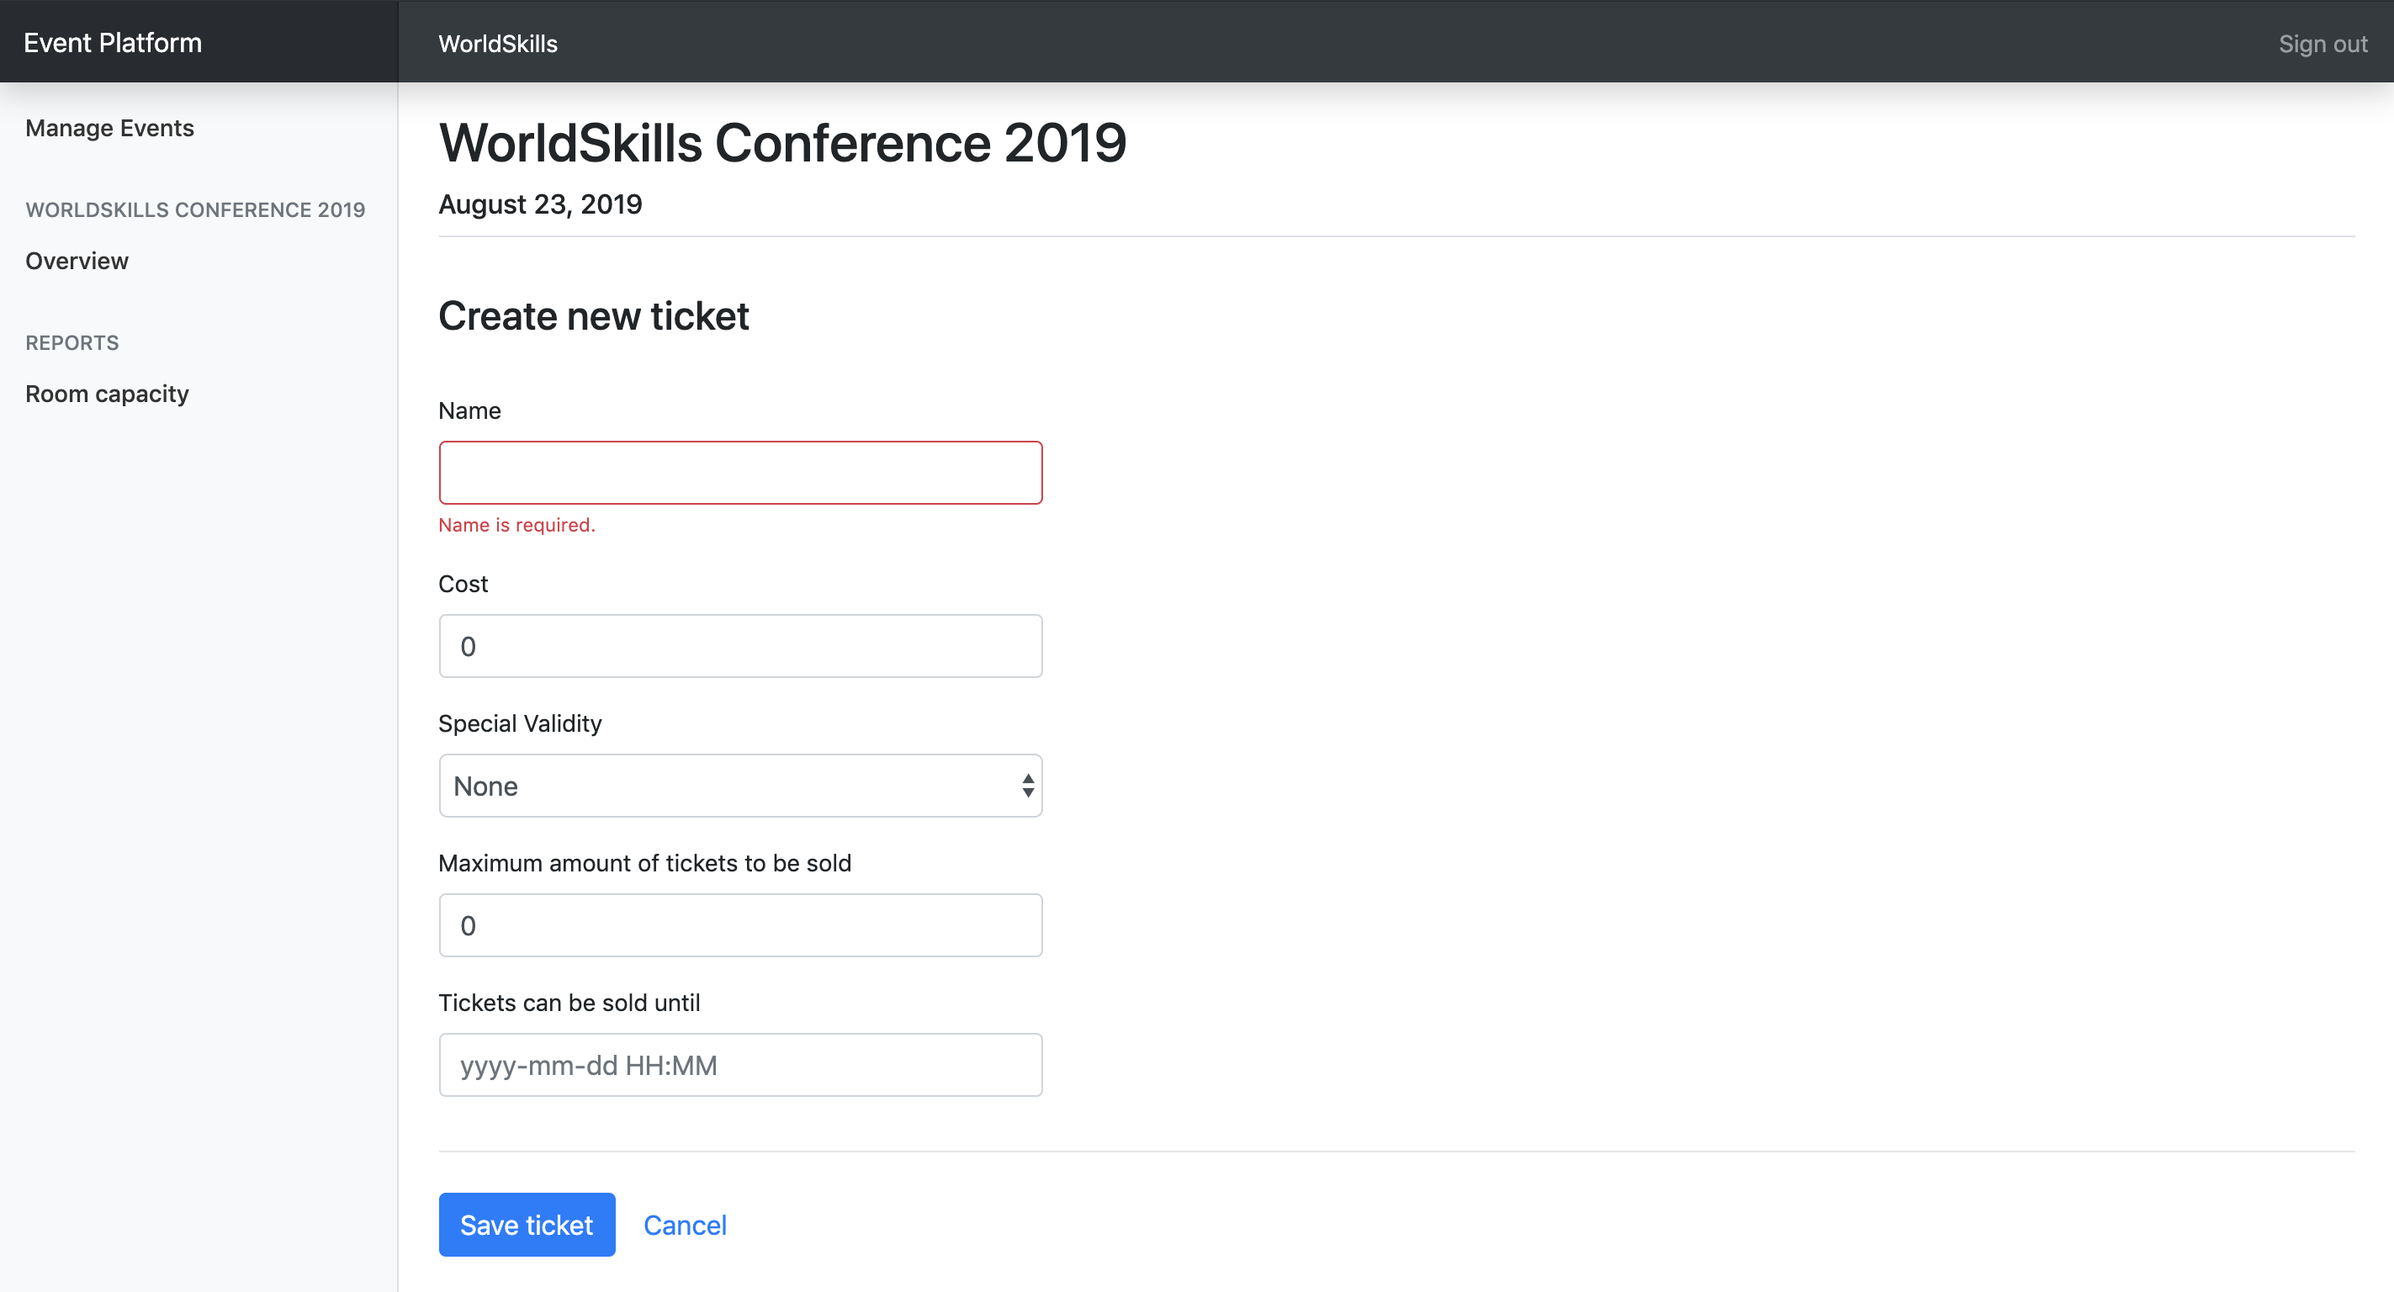

Scenario: A3b – Enter information for a new ticket
情境：A3b- 輸入新票券資訊
Given a form to enter session information is shown
假設輸入場次資訊的表單已出現
When I enter information for the ticket (
name and cost field are required, also any field that is related to the selected special validity rule)
輸入票券資訊 (name和cost為必填欄位，任何與特殊驗證規則有關的欄位也都必填)
And I press "Save ticket"
按下 "Save ticket"
Then the ticket is saved into the database
票券就會存到資料庫
And I am redirected to the detail page of the event it is assigned to
並重新導向至該票券的活動詳情頁面
And a success message "Ticket successfully created" is shown
顯示成功訊息 "Ticket successfully created"

Session management 場次管理
For every event, organizers want to be able to list the current sessions and have the possibility to create new ones. Sessions are always assigned to a room which can not have another session during that time. Sessions are one of these two types:
每一個活動中，主辦人要能夠列出目前的場次，並能新增場次。場次一定會分配到演講廳，演講廳不可同時有其他場次。場次為下列其中一種類型：
- talk: A speaker presents a talk. Talks are included in the conference ticket and do not cost extra.
演講：一位講者做一段演講，演講包含在研討會票券內，不另收費。
- workshop: A speaker holds a hand-on workshop with its attendees. Workshops can cost extra.
工作坊：一位講者為參加人員舉辦一場實作工作坊。工作坊可另外收費。
Specification: 規格：
Feature: A4 – Manage sessions: As an organizer I want to manage sessions that attendees can sign up for
功能: A4 – 管理場次：身為主辦人，我要管理場次，給參加人員報名

Scenario: A4a – Show form for new session
情境：A4a- 顯示新場次的表單
Given I am on the detail page of an event
假設我在一個活動的詳情頁面
And I press "Create new session"
按下"Create new session"
Then a form to enter session information appears
就會出現表單，可以輸入場次資訊

Scenario: A4b – Enter information for a new session
情境：A4b- 輸入新場次資訊
Given a form to enter session information is shown
假設已出現輸入場次資訊的表單
When I enter information for the session (all fields, except cost, required)
輸入場次資訊 (所有欄位都必填，除了cost)
And I press "Save session"
按下 "Save session"
Then the session is saved into the database
場次就存到資料庫
And I am redirected to the detail page of the event it is assigned to
並重新到項至該場次的活動詳情頁
And a success message "Session successfully created" is shown
顯示成功訊息 "Session successfully created"

Scenario: A4c – Enter invalid information for a new session – room booked
情境：A4c-在新場次輸入無效的資訊—已預訂的演講廳
Given a form to enter session information is shown
假設輸入場次資訊的表單已顯示
When I choose a room which already has another session at the same time
選擇一間已被其他場次預訂同一時間的演講廳
And I press "save session"
按下 "save session"
Then the session is not saved into the database
場次就不會存到資料庫
And an error message "Room already booked during this time" is shown
並顯示錯誤訊息 "Room already booked during this time"
And my previously submitted input data is not lost
先前成交的輸入資料並不會遺失

Scenario: A4d – Show form for updating session
情境：A4d-顯示更新場次用的表單
Given I am on the detail page of an event
假設在一個活動的詳情頁面
And I click on the name of a session
點擊一個場次名稱
Then a form to update session information appears
就會出現一個表單，可以更新場次資訊

Scenario: A4e – Update session information
情境：A4e- 更新場次資訊
Given a form to update information of an existing session
假設在更新現有場次的表單
When I change the prefilled old event information to new values
改變預填的舊活動資訊，並填入新值
And I press "Save session"
按下"Save session"
Then the updated session is saved into the database
更新後的場次就會存到資料庫
And I am redirected to the detail page of the event it is assigned to
並重新導向至該場次的活動詳情頁
And a success message "Session successfully updated" is shown
顯示成功訊息"Session successfully updated"

Channel management 頻道管理
A channel is used to group multiple sessions by a topic, for example management or user experience. Channels are assigned to exactly one event.
頻道是用來將多個活動場次，依主題分為一組，例如管理或使用者體驗。頻道只能被歸入一個活動中。
Specification: 規格 ：
Feature: A5 - Manage channels: As an organizer I want to manage channels of an event so sessions can get assigned to them
功能: A5 – 管理頻道：身為主辦人，我要管理一個活動的頻道，才能將場次指派到頻道

Scenario: A5a – Show form for new channel
情境：A5a- 顯示新頻道的表單
Given I am on the detail page of an event
假設在一個活動的詳情頁面
And I press "Create new channel"
按下 "Create new channel"
Then a form to enter channel information appears
就會出現一個表單，可輸入頻道資訊

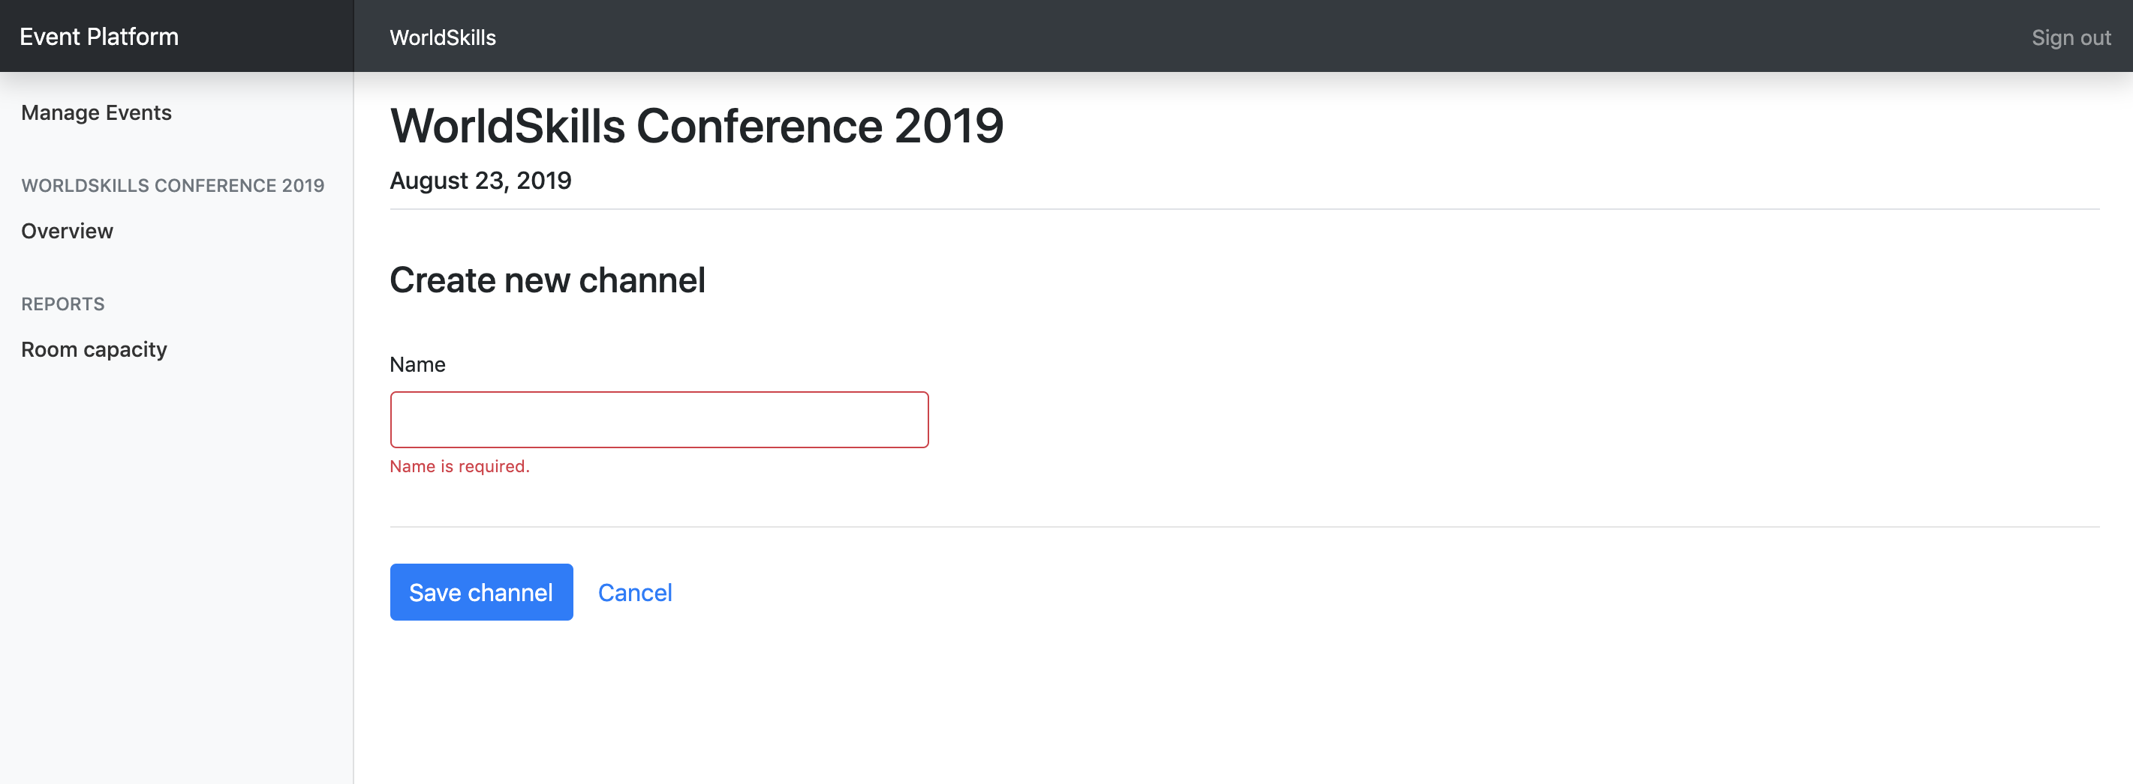

Scenario: A5b – Enter information for a new channel
情境：A5b – 輸入新頻道的資訊
Given a form to enter channel information is shown
假設輸入頻道資訊的表單已出現
When I enter information for the channel (all fields required)
輸入頻道資訊 (所有欄位皆必填)
And I press "Save channel"
按下 "Save channel"
Then the channel is saved into the database
頻道就會存至資料庫
And I am redirected to the detail page of the event it is assigned to
並重新導向至該頻道所屬活動的詳情頁面
And a success message "Channel successfully created" is shown
顯示成功訊息 "Channel successfully created"

Room management 演講廳管理
A room is assigned to exactly one channel and can have exactly one session at a time.
一間演講廳只能被派給一個頻道，且一次只能有一個場次。
Specification: 規格：
Feature: A6 – Manage rooms: As an organizer I want to manage rooms which I can later assign to sessions
功能: A6 – 管理演講廳：身為主辦人，我要管理演講廳，之後可以將演講廳指派到場次

Scenario: A6a – Show form for new room
情境：A6a- 顯示新演講廳的表單
Given I am on the detail page of an event
假設在一個活動的詳情頁面
And I press "Create new room"
按下"Create new room"
Then a form to enter room information appears
就會出現一個表單，可以輸入演講廳資訊

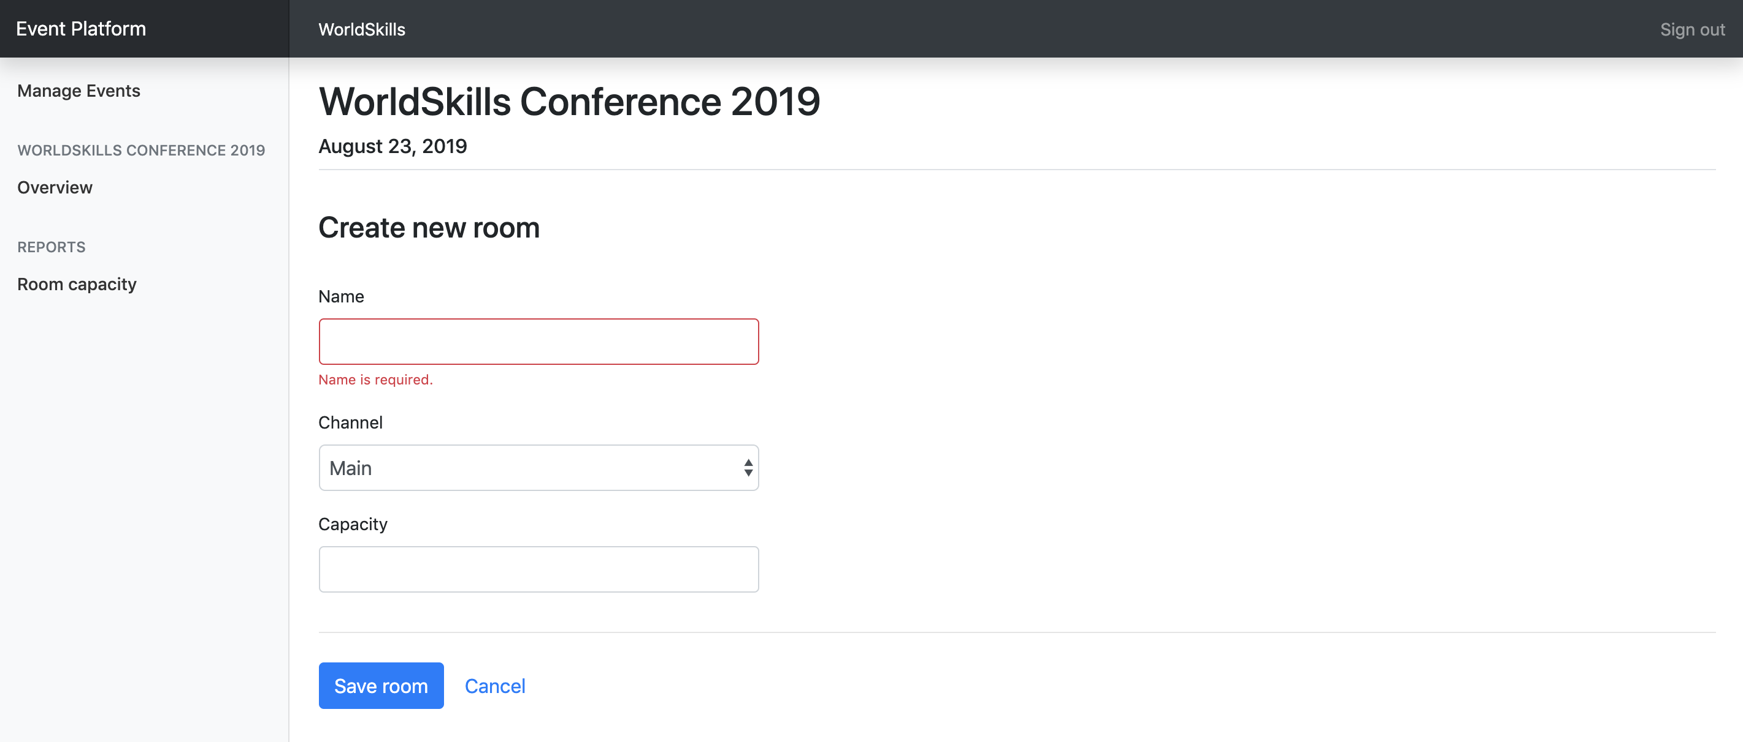
Scenario: A6b – Enter information for a new room
情境：A6b- 輸入新演講廳的資訊
Given a form to enter room information is shown
假設輸入演講廳資訊的表單已出現
When I enter information for the room (all fields required)
輸入演講廳資訊 (所有欄位皆必填)
And I press "Save room"
按下"Save room"
Then the room is saved into the database
演將廳就會存到資料庫
And I am redirected to the detail page of the event it is assigned to
重新導向至該演講廳所屬活動之詳情頁面
And a success message "Room successfully created" is shown
並顯示成功訊息"Room successfully created"

Room capacity 演講廳容納人數
Organizers want to see an overview of all sessions with information about the room capacity and number of attendees. With this information, they can see if a room is reaching its full capacity.
主辦人要看所有場次的總覽，包括演講廳容納人數與參加人數。有了這些資訊，他們可以看看演講廳是否將客滿。
Please note that for all sessions of type talk, attendees don't need a separate ticket. For sessions of type workshop, they need a separate ticket.
請注意，所有演講類型的場次，參加人員不須有另外的票券；而工作坊類型的場次則須要另外的票券。
Specification: 規格：
Feature: A7 – Room overview: As an organizer I want to see an overview of the sessions with the room capacity and number of attendees
功能: A7 – 演講廳總覽圖：身為主辦人，我要看場次總覽圖，包含演講廳容納人數與參加人數

Scenario: A7a – Show room overview
情境：A7a- 顯示演講廳總覽
Given I am on the detail page of an event
假設在一個活動的詳情頁面
When I press the link "Room capacity" in the sidebar
在側欄按下連結"Room capacity"
Then I see a bar chart displaying sessions along the horizontal axis,
while the y-axis is showing the room capacity superimposed with the
registered amount of attendees
就會看見長條圖，橫軸為場次，Y軸顯示演講廳可容納人數，並與已報名人數疊映在一起

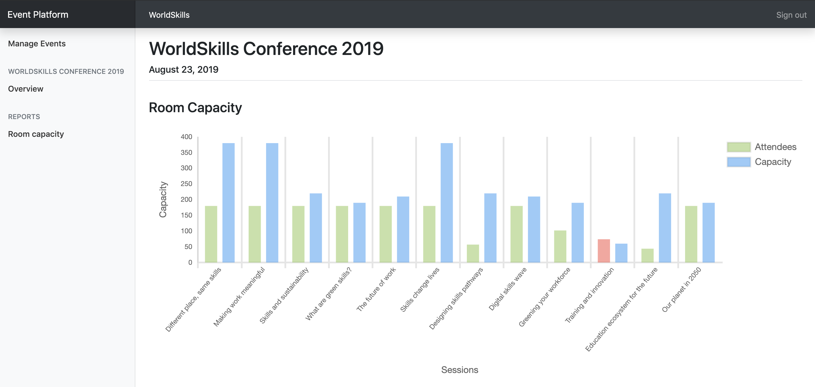

Scenario: A7b – Room capacity exceeded
情境：A7b- 演講廳容納人數已超過
Given I am on the "Room capacity" page
假設在"Room capacity"頁面
When I have a room which exceeds its capacity
有間演講廳超過了容納人數
Then I see the visitors bar highlighted with a red color instead of green
就會看見訪客人數長條被標記為紅色，而不是綠色

Attendee API 參加人員API
Create a RESTful API (http://<hostname>/XX_JS-PHP_A/api/v1/…) to
建立RESTful API(http://<hostname>/XX_JS-PHP_A/api/v1/…)，用以
- login and logout as an attendee 登入及登出參加人員身份
- read all upcoming events 瀏覽所有近期活動
- see the agenda for an event 瀏覽一場活動的議程
- sign up and purchase a ticket for an event 報名活動與購票

PHPUnit tests PHPUnit測試
Tests for the PHP API are distributed with the mediafiles. Please see the following instructions to set them up and configure on your own server.
PHP API的測試會跟多媒體檔一起提供，請見下列指示，安裝並設定在自己的伺服器。
Setup: 安裝
- Upload the API tests to your server 將API測試上傳至你的伺服器
- Configure the .env file of the API tests and provide correct database credentials and the URL where your API is available. 設定API測試的.env檔，並提供正確的資料庫驗證資料，以及連至API的URL。
Running the tests: 進行測試：
Execute the following command on the server inside the directory of the api tests:
在api測試目錄內的伺服器執行下列指令：
composer test
To only run a single test, you can use the following command for example:
要進行單一測試，你可以使用下列指令，如：
composer test -- --filter B2EventDetailTest

Additional information for the REST-API tests/specification: the body contains some static example data, adjust it to fit the requirements. Placeholder parameters in the URL are marked with curly braces: {slug}
其他REST-API測試/規格的資訊：body包含了一些固定的範例資料，請調整這些資料以符合要求。URL的Placeholder參數以大括弧標示：{slug}
The tests are referenced by its function name [-> test<scenario-id><text>].
測試有參照功能名稱[-> test<scenario-id><text>]
The order of properties in objects does not matter, but the order of items in an array does.
物件屬性的順序不重要，但是矩陣項目的順序很重要。

Events overview 活動總覽
When an attendee lands on the index page of the application, he will get a list with all upcoming events across all organizers. Events should be ordered ascendilgly by their date.
一位參加人員進入應用程式索引頁(index page)的時候，將得到所有主辦人的所有近期活動清單。活動的順序應依照日期由舊至新排列。
Specification: 規格：
Feature: B1 – Read events: As a visitor I want to read the public data of all upcoming events so that I can display them in a list
功能: B1 –瀏覽活動：身為訪客，我要瀏覽所有近期活動的公開資料，好用列表顯示

Scenario: B1a – Read all upcoming events
情境：B1a- 瀏覽所有近期活動
Request
URL: /api/v1/events
Method: GET
Header:
Body: -
Response
If success [-> testB1aGetEvents]
Header: Response code: 200
Body: {"events": [{"id": 1, "name": "someText", "slug": "some-text", "date": "2019-08-15", "organizer": {"id": 1, "name": "someText", "slug": "some-text"}}]}

Event detail 活動細項
When an event is selected, all information of the selected event should be returned in the same endpoint.
選擇一個活動後，該活動的所有資訊都應回到同一端點。
If a session has no cost or a ticket no description, NULL will be used.
若一個場次沒有花費，或票券無敘述，則使用NULL。
The description of a ticket is generated as following:
票券敘述的產生如下：
- NULL if no special validity rule set
若無設定特殊驗證規則，則為NULL
- "Available until {month} {day}, {year}" if special validity rule "date" is used
(example: "Available until September 1, 2019")
若有使用特殊“日期” 驗證規則，則為"Available until {month} {day}, {year}"
(如: "Available until September 1, 2019")
- "X tickets available" if special validity rule "amount" is used
(example: "30 tickets available" where 30 is the total amount of tickets and not the remaining ones)
若使用特殊 “數量”驗證規則，則為"X tickets available" if special validity rule "
(如: "30 tickets available" 為總量30張，而非剩餘30張)
Specification: 規格：
Feature: B2 - Read event: As a visitor I want to read all information about an event
功能: B2 –瀏覽活動：身為訪客，我要瀏覽一個活動的所有資訊

Scenario: B2a – Read all detail information of a single event
情境：B2a- 瀏覽單一活動的所有詳細資訊
Request
URL: /api/v1/organizers/{organizer-slug}/events/{event-slug}
Method: GET
Header:
Body: -
Response
If success [-> testB2aGetEventDetail | testB2aTicketValidity]
Header: Response code: 200
Body: {"id": 1, "name": "someText", "slug": "some-text", "date": "2019-08-15", "channels": [{"id": 1, "name": "someText", "rooms": [{"id": 1, "name": "someText", "sessions": [{"id": 1, "title": "someText", "description": "someText", "speaker": "someText", "start": "2019-08-15 10:00:00", "end": "2019-08-15 10:45:00", "type": "workshop", "cost": 50|null}]}]}], "tickets": [{"id": 1, "name": "someText", "description": "Available until July 7, 2019"|null, "cost": 199.99, "available": true}]}
If event does not exist or was not created by the organizer [-> testB2aGetInvalidEvent]
Header: Response code: 404
Body: {"message": "Event not found"}
If organizer does not exist [-> testB2aGetInvalidOrganizer]
Header: Response code: 404
Body: {"message": "Organizer not found"}

Attendee login and logout 參加人員登入及登出
After signup (which is not within the scope of this project), attendees get assigned a random 6 characters long registration code which they need when entering an event. To avoid requiring yet another password, this registration code is also used for logging the user in on the website, together with his lastname as his login credentials. The registration code is shared across all events and is not only valid for a single event.
報名後 (報名非本試題範圍)，參加人員會收到隨機六個字元的報名碼，在參加活動時會需要用到。為了不需要另一組密碼，使用者登入網站時也用同一組報名碼，同時須輸入使用者姓氏，作為登入身分驗證。這組報名碼適用所有活動，並非僅限單一個活動。
For testing purposes, the registration code and last name can be seen in the database dump.
為了測試，報名碼及姓氏可以在資料庫dump找到。
On a successful login, data of the loggedin attendee gets returned together with a token which can be sumitted with subsequent requests. For simplicity, the token is the username md5-hashed and is valid until the logout endpoint is called.
登入成功時，線上參加人員的資料會與一個token一起回傳，token可以與後續的request一起提交。為了簡化，token是username md5-hashed，且在登出端點呼叫前為有效。
Specification: 規格：
Feature: B3 - Login and Logout as atteendee: As a visitor I want to login/logout so that I can attend an event and see my registrations
功能: B3 – 以參加人員身分登入登出：身為訪客，我想要登入/登出，以參加活動和瀏覽我的報名資訊

Scenario: B3a - Attendee login
情境：B3a- 參加人員登入
Request
URL: /api/v1/login
Method: POST
Header:
Body: {"lastname": "someText", "registration_code": "someText"}
Response
If success [-> testB3aCorrectLogin|SameLastname|SameRegistrationCode]
Header: Response code: 200
Body: {"firstname: "someText", "lastname": "someText", "username": "someText", "email": "someText", "token": "AUTHORIZATION_TOKEN"} (md5 hashed username, valid until logout)
If user login info not correct [-> testB3aInvalidLastname|RegistrationCode|Request]
Header: Response code: 401
Body: {"message": "Invalid login"}

Scenario: B3b – Attendee logout
情境：B3b- 參加人員登出
Request
URL: /api/v1/logout?token={AUTHORIZATION_TOKEN}
Method: POST
Header:
Body: -
Response
If success [-> testB3bLogout]
Header: Response code: 200
Body: {"message": "Logout success"}
If invalid token [-> testB3bInvalidToken | testB3bAlreadyLoggedOut]
Header: Response code: 401
Body: {"message": "Invalid token"}

Event registration 活動報名
Users will register and buy a ticket with this endpoint. The different ticket validity rules (date or amount) should be validated. Registrations should be sorted ascendingly by their id.
使用者將用此端點來報名、購票。不同票券驗證規則 (日期或數量)應受驗證。報名資料應依id順序遞升排列。
Specification: 規格：
Feature: B4 – Event registration: As a visitor I want to register for an event
功能: B4 –活動報名資訊：身為訪客，我想要報名活動

Scenario: B4a – New event registration
情境：B4a- 報名新活動
Request
URL: /api/v1/organizers/{organizer-slug}/events/{event-slug}/registration?token={AUTHORIZATION_TOKEN}
Method: POST
Header:
Body: {"ticket_id": 1, "session_ids": [1, 2, 3]} (session_ids is optional)
Response
If success [-> testB4aCorrectRegistration]
Header: Response code: 200
Body: {"message": "Registration successful"}
If user is not logged in or token is invalid [-> testB4aLoggedOut]
Header: Response code: 401
Body: {"message": "User not logged in"}
If user already registered for this event [-> testB4aAlreadyRegistered]
Header: Response code: 401
Body: {"message": "User already registered"}
If ticket is not available anymore [-> testB4aInvalidTicket]
Header: Response code: 401
Body: {"message": "Ticket is no longer available"}

Scenario: B4b – Get registrations of a user
情境：B4b- 獲得一位使用者的報名資訊
Request
URL: /api/v1/registrations?token={AUTHORIZATION_TOKEN}
Method: GET
Header:
Body: -
Response
If success [-> testB4bGetRegistrations | testB4bNewRegistration]
Header: Response code: 200
Body: {"registrations": [{"event": {"id": 1, "name": "someText", "slug": "some-text", "date": "2019-08-15", "organizer": {"id": 1, "name": "someText", "slug": "some-text"}}, "session_ids": [1, 2, 3]}]}
If user is not logged in or token is invalid [-> testB4bLoggedOut]
Header: Response code: 401
Body: {"message": "User not logged in"}

Phase two – JavaScript 第二階段- JavaScript

API Setup API設定
The API needed for this part will be provided after lunch and can be set up with the following instructions. In case you want to start with part two before lunch, you have to use your own API from part one.
這個部分需要的API將會在午餐後提供，可經由下列指示安裝。若想在午餐前開始進行第二部分，必須使用自己在第一部份的API。
Automated setup: 自動安裝
Connect to your server through SSH and execute the following command (in your home directory):
透過SSH連結至你的伺服器，並執行下列指令 (在你的home目錄)：
setup-api
This will automatically set up the API and database on your server. After completion, the API is available at http://XX.skill17.com/day2-afternoon/ (XX is your workstation number).
這會自動在伺服器安裝API和資料庫。完成之後，API會提供在 http://XX.skill17.com/day2-afternoon (XX 為工作站代碼)
The API is implemented according to the specification of the Attendees API in part one.
API的實作要按照第一部分參加人員API的規格。
Manual setup: 手動安裝：
The manual setup should only be done in case the automatic setup fails.
手動安裝僅限在無法自動安裝時使用。
- Download the API from http://wsi.skill17.com/day2_afternoon_api.zip (only available in the afternoon)
下載API，連結為http://wsi.skill17.com/day2_afternoon_api.zip (下午才會提供)
- Upload it to your server and unzip it into the folder /home/competitor/www/day2-afternoon (ensure that the unzipped files files are directly located in the folder /home/competitor/www/day2-afternoon and not in another subfolder)
上傳至你的伺服器並解壓縮存至資料夾/home/competitor/www/day2-afternoon (請確認解壓縮後，檔案都直接放在資料夾/home/competitor/www/day2-afternoon，而不是另一個子資料夾)
- Create a new database called day2_afternoon and import the provided dump from part one
建立新的資料庫，名為day2_afternoon，並匯入第一部分提供的dump
- The API is now available at http://XX.skill17.com/day2-afternoon/ (XX is your workstation number)
API現已提供在http://XX.skill17.com/day2-afternoon/ (XX為工作站代碼)

Introduction 介紹
Using the RESTful API (all data coming/going into database), create a frontend for attendees to browse information about the events, login/logout and register for an event. During registration, it should be possible to add additional workshops they want to attend.
使用RESTful API (所有資料輸入/輸出資料庫)，建立一個前台給參加人員瀏覽活動資訊、登入/登出和報名活動。在報名時，應可新增他們想參加的工作坊。
The RESTful API supports POST requests with JSON or FormData bodies, but the correct request headers need to be set accordingly to the used body type.
RESTful API支援有JSON或FormData bodies的POST requests，但正確的request頁首必須依照已使用body type來設定。
Interaction should show error/feedback messages based on response from the API where appropriate. Also, an error page should be shown when accessing an invalid URL.
互動應根據API的response來適當顯示錯誤/回饋訊息。另外，存取無效URL時，應顯示錯誤頁面。
Browsing all data is public and no user is required. But as soon as they want to register for an event, they need to be signed in.
所有資料皆供公開瀏覽，不須使用者身分，但若要報名活動，就必須登入。
Refreshing a page should always display the same page and it must be possible to share a page by URL so that all state is kept in the URL.
重新整理頁面時，應顯示同一頁面，必須能夠用URL來分享頁面，讓所有狀態都保留在URL。
The layout should follow mockups exactly. The position of elemenst in design should be same as mockups.
版面要完全按照mockup，設計中元素的位置應和mockup相同。

The yellow bubbles in the mockups show classes and ids which have to be used for those elements to allow running automated tests. The yellow bubbles are not part of the design and do not have to be displayed in the browser.
mockup黃色標記處顯示的class和id，必須使用在那些元素，以進行自動測試。這些黃色標記並非設計的部分，且不須在瀏覽器中顯示。

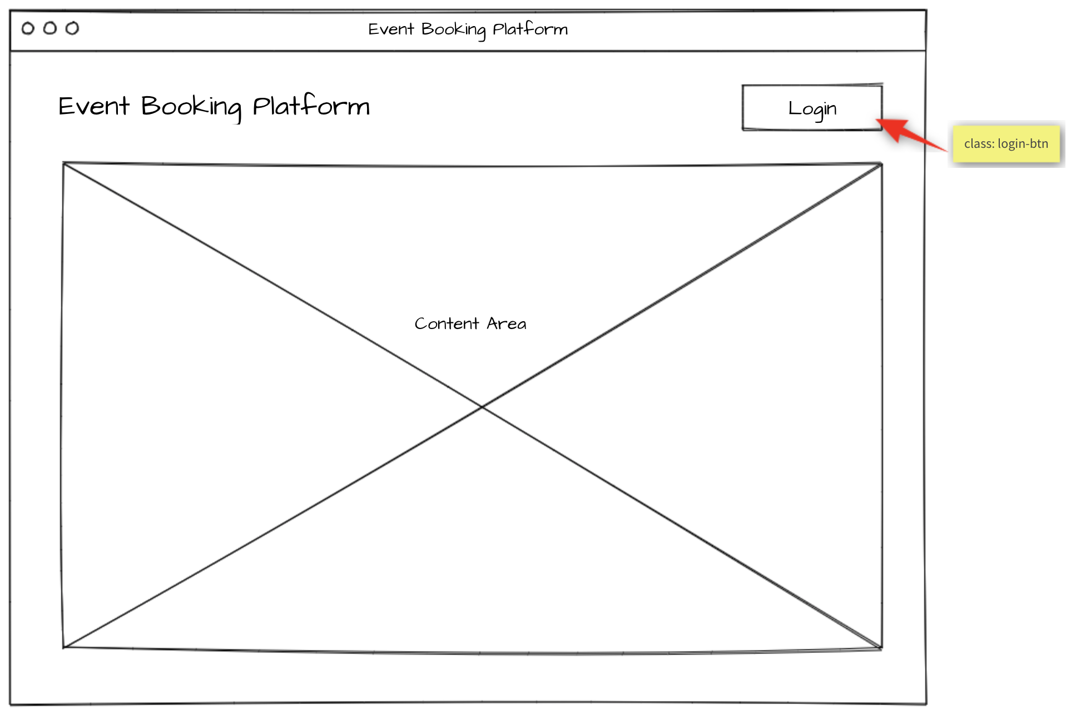

Events list 活動列表
When accessing the index page, all upcoming events are displayed with their organizer name and the date it takes place. By selecting an event, the event agenda will be shown.
存取索引頁(index page)時，顯示出所有近期活動，以及各個活動的主辦方名稱、活動日期。選取一個活動，就會顯示活動議程。
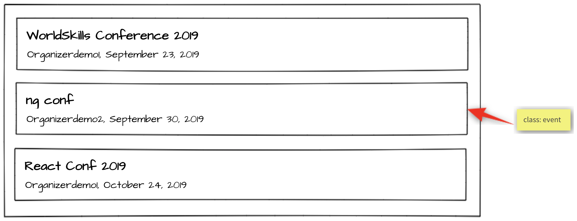
Specification: 規格：
Feature C1 - List upcoming events: As an attendee, I want to see what events I can attend.
功能C1- 列出近期活動：身為參加人員，我要看看有什麼活動能參加

Scenario: C1a - List upcoming events
情境：C1a- 列出近期活動
Given I am on the home page
假設在首頁
Then I see a chronologically ordered list of upcoming events across all
organizers
我會看到近期活動列表，活動照時間順序排列，且範圍橫跨所有主辦人。
And I can click on an event
我能點擊一個活動

Event agenda 活動議程
The agenda of the selected event is shown. If the user is logged in and is already registered for this event, all sessions with type talk are highlighted with a green border since they are automatically included in every event registration. Additionally, if the user signed up for addition sessions of type workshop, they will also be highlighted with a green border.
顯示選定活動的議程。若使用者已登入，且已報名該活動，所有演講類型的場次都會標記為綠色邊框，因為這些場次都自動包含在每個活動報名資料內了。而且，若使用者報名工作坊類型的其他場次，也會標記為綠色邊框。
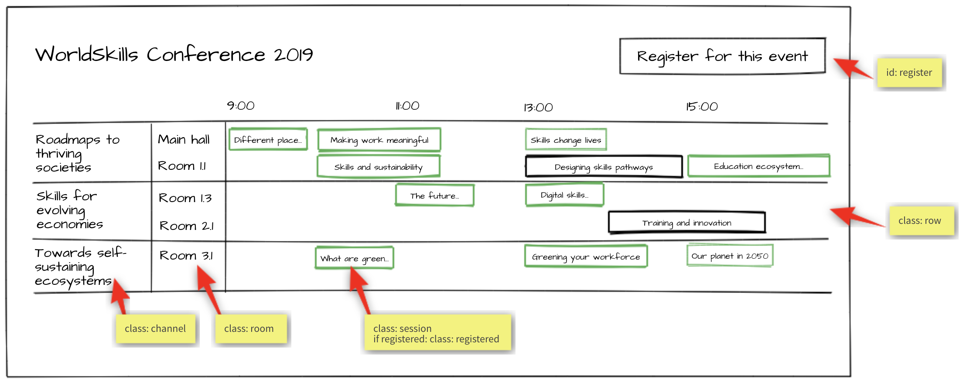
Specification: 規格：
Feature C2 - Display event agenda: As an attendee, I want to see what sessions are within an event.
功能: C2 – 展示活動議程：身為參加人員，我要看有哪些場次包含在一場活動中

Scenario: C2a - Display channels
情境：C2a- 顯示頻道
Given I am on an event detail page
假設在一個活動的詳情頁
Then I see the channels of the event forming horizontal swimlanes
我會看到這個活動的頻道組成水平泳道圖
And the channels contain the rooms as "inside"-swimlanes
這些頻道將演講廳包含在泳道圖 “裡面”

Scenario: C2b - Display talk and workshop sessions
情境：C2b- 顯示演講及工作坊的場次
Given I am on an event detail page
假設在一個活動的詳情頁
Then I see the timeline containing "9:00", "11:00", "13:00", "15:00"
我會看到時間軸，包括"9:00"、"11:00"、"13:00"、"15:00"
And I see the sessions in the correct room swimlane starting and ending
at the correct time
並顯示場次位在正確的演講廳泳道，開始及結束時間都正確

Scenario: C2c - Display registered sessions
情境：C2c- 顯示已報名的場次
Given I am on an event detail page
假設在一個活動的詳情頁
And I am logged in
而我已登入
And I am already registered for this event
且已報名這個活動
Then I see all sessions of type talk highlighted with a green border
那就能看到所有演講類型的場次，標記為綠色邊框
And I see all sessions of type workshop which I have signed up for
highlighted with a green border
看到所有工作坊類型且已報名的場次，標記為綠色邊框

Session detail 場次細項
When clicking on a session within the agenda, a detail page showing all information about this session will be shown.
在議程中點選一個場次，會有一個詳細的頁面，顯示關於這個場次的所有資訊。
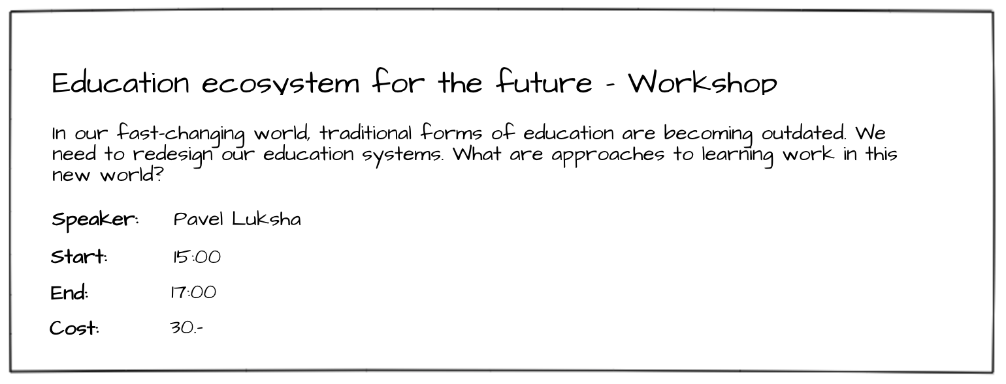
Specification: 規格：
Feature C3 - Display session details: As an attendee, I want to inform myself about the details of a session.
功能: C3 – 展示場次細項：身為參加人員，我想找到場次的細項。

Scenario: C3a - Display session details
情境：C3a- 顯示場次細項
Given I am on an event detail page
假設在一個活動的詳情頁
When I click on a session
點擊一個場次
Then I see a detail page of the session containing title, description,
speaker, start and end time, type and the cost (if it is set)
就會看見該場次的詳情頁面，包括標題、描述、講者、開始與結束時間、類型與花費 (若已設定)

Event registration 活動報名
After clicking on "register for this event", the user either sees the event registration form if he is logged in or gets redirected to the login form if he is not logged in.
點選 "register for this event"之後，使用者若已登入，會看見活動報名表單，而若使用者未登入，則重新導向登入表單。
On the event registration form, he can select the ticket type he wants. Unavailable tickets are greyed out and can't be selected. The API is responsible for this information and the validation, so it does not have to be handled in the frontend.
在活動報名表單，可選擇想要的票券類別。不開放的票券為灰色，且無法點選。API負責這項資訊與驗證，因此不須在前台處理。
The user can also select additional sessions of type workshop he wants to attend. If a session has an additional cost, it will show up in the cost view and add to the total cost.
使用者也可選擇想參加的工作坊類型其他場次，若一個場次需要額外收費，則顯示在收費一覽表並新增至總花費。
After clicking on "Purchase", the user will be registered for this event and the sessions he has selected and gets redirected back to the event detail page.
點選 “Purchase”之後，使用者就完成了選定活動及場次的報名， 並重新導向回活動細項頁面。
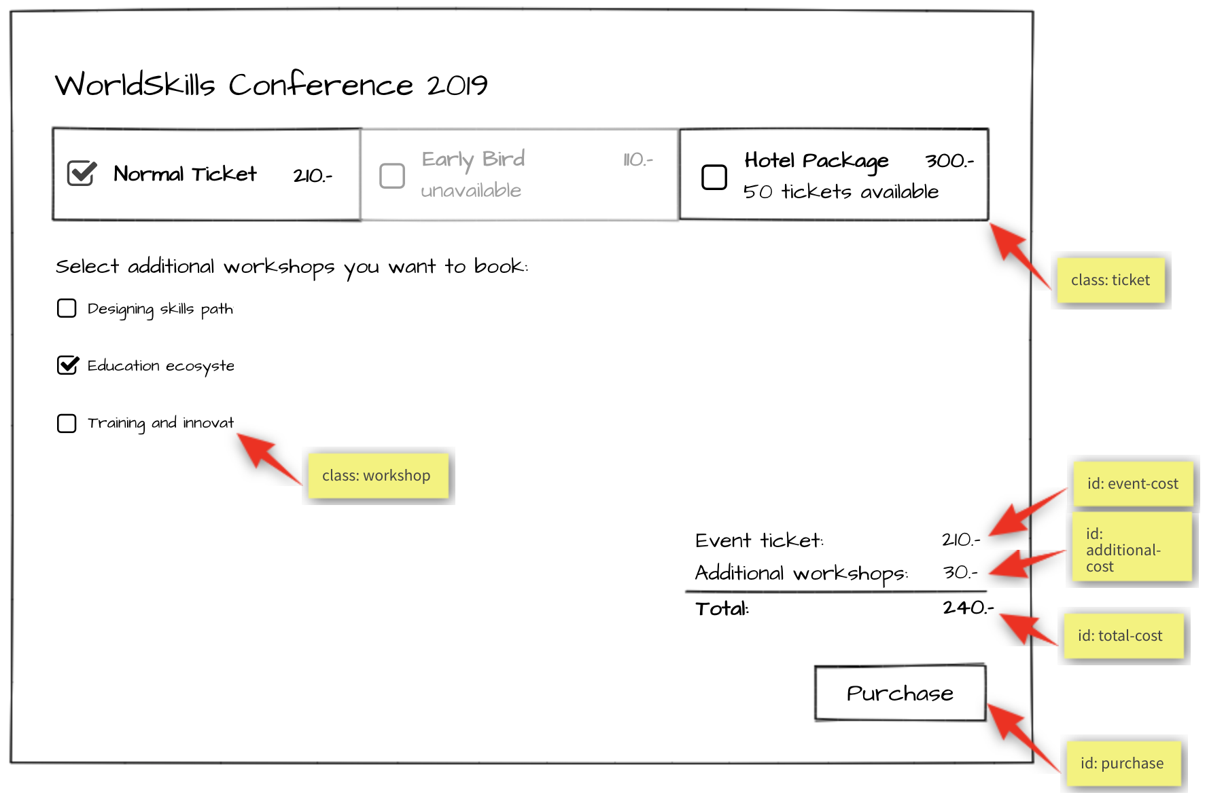

Specification: 規格：

Feature: C4 - Register for event: As an attendee, I want to be able to register for an event and pay the admission fee.
功能: C4 – 報名活動: 身為參加人員，我要能夠報名一個活動，並付門票費用

Scenario: C4a - Enter registration mode
情境：C4a – 輸入報名資訊模式
Given I am on an event detail page
假設在一個活動的詳情頁
And I am logged in
已登入
Then I can click on a button to enter registration mode
接著我將點擊一個按鈕或輸入報名模式
And I see the ticket types and their cost
我看見ticket types和各自的花費
And I see a checkbox list of sessions of type workshop
看見一個可勾選的，工作坊類型場次的場次清單。
And I see a cost view summary
我會看到花費一覽表
And I see a disabled "Purchase" button
並顯示未啟用的 "Purchase" 按鈕

Scenario: C4b - Select ticket success
情境：C4b- 選擇票券成功
Given I am in registration mode of an event
假設在一個活動的報名模式
When I select a ticket that is available
選擇有開放的票券
Then the ticket cost is displayed in the cost view summary
票券花費就會顯示在花費一覽表裡
And the "Purchase" button is enabled
且 "Purchase" 按鈕已啟用

Scenario: C4c - Select ticket fail
情境：C4c- 選擇票券失敗
Given I am in registration mode of an event
假設在一個活動的報名模式
When I select a ticket that is not available
選擇的票券未開放
Then the ticket is not selected
票券就不會被選擇
And the "Purchase" button is not enabled
且 "Purchase" 按鈕不會被啟用

Scenario: C4d - Select workshop session
情境：C4d- 選擇工作坊場次
Given I am in registration mode in an event
假設在一個活動的報名模式
When I tick a workshop session
勾選工作坊場次
Then the session receives a tick
這個場次就被勾選起來
And the price of the workshop is displayed under "Additional workshops" in
in the cost view
工作坊的票價會顯示在花費一覽表"Additional workshops"下方
And the price of the session is added to the total cost
且該場次的票價會加到總花費裡

Scenario: C4e – Purchase
情境：C4e- 購買
Given I am in registration mode in an event
假設在一個活動的報名模式
When I select a ticket and I press the "Purchase” button
選擇一個票券並按下"Purchase”按鈕
Then the registration is saved
報名資料就儲存了
And I get redirected to the event agenda
並且重新導向至活動議程
And a message appears "Registration successful"
顯示訊息"Registration successful"

Attendee login 參加人員登入
When registering for an event, a login is required. After a successful login, the login button in the navigation should no longer be visible. Instead, the username of the currently logged in user should be displayed and a button to log out.
報名一場活動時，需要先登入。成功登入後，導覽列的登入鈕不應顯示，目前登入的使用者名稱應顯示，還有登出鈕。
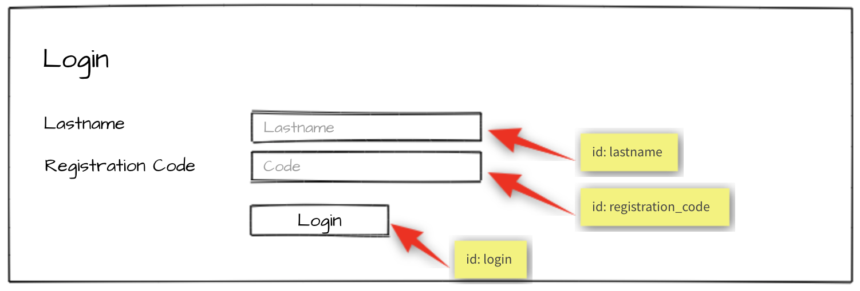
Specification: 規格：
Feature: C5 – Log in and log out as an attendee: As an attendee, I would like to log in and log out to the event
platform so that I can access my registrations and register for new events.
功能: C5 – 登入登出參加人員身分：身為參加人員，我像要登入和登出活動平台，已存取我的報名資訊，和報名新活動

Scenario: C5a - Attendee login ok
情境：C5a- 參加人員登入ok
Given I am on the "login" page
假設在"login"頁面
When I enter the specified lastname and registration code for an attendee
輸入參加人員特定的姓氏和報名碼
And press the "Login" button
按下"Login"按鈕
Then I'm forwarded to the previous page
就會轉到前一頁
And username and "Logout" button become visible in the header
並在header顯示使用者名稱及"Logout"按鈕

Scenario: C5b - Attendee login fail
情境：C5b- 參加人員登入失敗
Given I am on the "login" page
假設在"login"頁面
When I enter a wrong lastname and registration code for an attendee
輸入錯誤的參加人員姓氏和報名碼
And press the "Login" button
按下 "Login"按鈕
Then I stay on the "login" page
會停留在 "login"頁
And I see an error message "Lastname or registration code not correct"
並看見錯誤訊息"Lastname or registration code not correct"

Scenario: C5c - Attendee logout
情境：C5c- 參加人員登出
Given I am logged in
假設我已登入
When I press the "Logout" button
按下 "Logout"按鈕
Then I am forwarded to the "login" page
就會轉到 "login"頁
And username and logout button disappear
使用者名稱與登出鈕都會消失
And I cannot reach the previous page by going back
我無法按上一頁回到前一個頁面

Notes 注意事項
- When you are done with the first phase resp. after lunch you may continue with the second phase.
完成第一階段 resp.後，午餐後可繼續做第二部分。
- If you are done with part one before the lunch break, you can start with part two by using your own API and exchange it at the start of the afternoon with the provided API.
若在午休前你已完成第一部分，可以使用自己的API開始第二部分，並在下午一開始就換成提供的API。
- Competitors must use one of the server-side and client-side frameworks/libraries that are provided.
選手必須使用已提供的其中一款伺服端和客戶端框架/函式庫。
- The provided template for the admin interface should be used. It can be enhanced to get better functionality for your site. The visual design of the admin interface will not be assessed.
應使用已提供的管理者介面模板，可以加強自己的網站，以達成更好的功能。管理者介面的視覺設計將不列入評分。
- The design of the attendee interface can be based on the template of the admin interface. The visual design of the attendee interface will be assessed: a simple, clean and attractive design is expected, including choice of colors, typography and spacing.
參加人員介面可以依據管理者介面模板來做。參加人員介面的外觀將會受評分：希望是簡潔、乾淨、好看的設計，包括顏色、字型、留白的選擇。
The design should be optimized for a minium window width of 1024px.
這項設計要最佳化，最小視窗寬度為1024px。
- For the admin interface it is important to use the selectors (class, id) as provided in the template. For the attendee interface it is important to use the selectors (class, id) as specified in the screen mockup (yellow bubbles).
管理者介面要使用selectors (class, id)，如模板所提供。參加人員介面要使用selectors (class, id)，如畫面mockup中標示的 (黃色標記)。
- The specified database tables need to be implemented as provided. More tables may be added if needed. The given tables must not be changed. Provide a final SQL-dump and ERD screen as specified below.
指定的資料庫table需要如已提供的來實作，若有需要，可新增更多table，已提供的table不可變更。請提供最終的SQL-dump和ERD畫面，如下所示。

- The API implementation should fulfill all requirements as stated in the description. All prefixes, RESTful-URLs and HTTP-Methods from the given API links must be implemented correctly and cannot be changed.
API的實作應符合敘述中的所有要求。從已提供的API連結裡，所有的prefix、RESTful-URL、HTTP-Method，都必須正確實行而不可更改。
- Changes made in the data need to be propagated between frontend and backend in both directions.
任何資料的變更都必須前後台通用，且為雙向。
- Update the first two organizers in the provided dump so it is possible to login to the system during assessment:
更新已提供的dump內頭兩個主辦人，才可以在評分時登入系統：
  - Organizer accounts: 主辦人帳號：
    - Email: demo1@worldskills.org Password: demopass1
    - Email: demo2@worldskills.org Password: demopass2
- For the room capacity bar chart, you can use one of the provided JS-libraries (Charts.js, D3.js)
要做演講廳容納人數的長條圖，可以使用提供的其中一個JS-libraries (Charts.js, D3.js)

Submission Instructions to the Competitor
選手遞交檔案的指示
Morning: Files to be collected after the first phase on the server:
上午：第一階段後在server上抓取的檔案：
- Web service (http://<hostname>/XX_JS-PHP_A/api/v1/..)
網路服務(http://<hostname>/XX_JS-PHP_A/api/v1/..)
- Admin area (http://<hostname>/XX_JS-PHP_A/) - initially shows login page
管理者專區( http://<hostname>/XX_JS-PHP_A/) (最先會顯示登入頁)
- Folder inside webroot (XX_JS-PHP_A/)
webroot內的資料夾 (XX_JS-PHP_A/)
- ERD screenshot named “XX_ERD.png” in “db-dump” folder inside of XX_JS-PHP_A
ERD畫面截圖，命名為“XX_ERD.png” in “db-dump”資料夾，位在XX_JS-PHP_A裡面
- Database dump named “XX_database.sql” in “db-dump” folder inside of XX_JS-PHP_A
名為“XX_database.sql” in “db-dump”的資料庫dump資料夾，位在XX_JS-PHP_A裡面
Afternoon: Files to be collected after the second phase on the server:
下午：第二階段後在server上抓取的檔案：
- Front-end website (http://<hostname>/XX_JS-PHP_B/)
前台網站(http://<hostname>/XX_JS-PHP_B/)
- Folder inside webroot (XX_JS-PHP_B/) - put all development files into XX_JS-PHP_B_dev.zip and leave only files for production-use in this directory.
webroot內的資料夾 (XX_JS-PHP_B/) 把所有開發檔放進XX_JS-PHP_B_dev.zip，此目錄只留製做用的檔案。
- If the front-end root (http://<hostname>/XX_JS-PHP_B) does not open the main page directly, have it open an index.html with a link to the main page for marking your front-end.
若前台root (http://<hostname>/XX_JS-PHP_B) 不能直接開啟首頁，讓它開啟有首頁連結的一個index.html，以進行前台評分。
XX is your country code XX是你的國家代碼。
The Web Service / REST-API will be assessed with the automated test-framework provided. Additional data may be used to test dynamic behavior.
Web Service / REST-AP將用已提供的自動測試框架(automated test-framework)來評分。額外的資料可用於測試動態行為。
It is recommended that you run the automated tests for the REST-API after implementing it locally or at least after uploading it to the server. Instructions to setup and use the tests for the API: see README.md in tests_api-php.
建議你在本機做完REST-API之後，進行自動測試，或至少在上傳至伺服器後測試。API測試的設定和使用方法：請見README.md in tests_api-php.
Manual assessment of other parts will be done using Google Chrome.
其餘部分的人工評分會使用Google Chrome。

Equipment, machinery, installations, and materials required需要的設備、裝置、安裝、素材
It is expected that all Test Projects can be accomplished by Competitors based on the equipment and materials specified in the Infrastructure List*.
希望選手能以IL表上指定的設備及素材來完成所有試題。
If any equipment or material is required that is not listed in the Infrastructure List, then it has to be listed here (in the table below - column headings may vary from skill to skill.)
若需要任何設備或素材但並非IL表上所列項目，則需列於此(下方的表格欄位可依不同職類變動)
WorldSkills International needs to approve any additional infrastructure requirements that are not listed in the Infrastructure List. Column headings may vary from skill to skill.
國際技能競賽需要審核未列於IL表上的所有額外基礎設備要求。欄位標題可依職類不同。
* (Definition: the Infrastructure List is the equipment, machinery, installations and materials supplied by the host country – it does not include tools and material to be supplied by Competitors and/or Experts)
* (定義：IL表列出由競賽主辦方供應的設備、裝置、安裝和素材，不包含由選手和/或裁判提供的工具和素材)
ITEM | description
Media Files | Contains:  - DB dump  - Template files for the admin-gui  - Charts.js & D3.js incl. Documentation  - Files for testing REST-API

Marking Scheme
SECTION | CRITERION | JUDG. MARKS | MEAS. MARKS | TOTAL
C1 | Database | 1.75 | 1.5 | 3.25
C2 | Admin Backend | 0 | 3.25 | 3.25
C3 | Ticket and Session | 0 | 1.5 | 1.5
C4 | Organizer | 1 | 2.25 | 3.25
C5 | REST API | 1.5 | 2.25 | 3.75
D1 | Events list and agenda | 0 | 3.75 | 3.75
D2 | Session and Events | 0 | 3 | 3
D3 | General | 1 | 3 | 4
D4 | JS Quality | 2.5 | 0 | 2.5
D5 | Front end design | 3 | 0 | 3
TOTAL |  | 10.75 | 20.5 | 31.25

